**Test validation**

**Case 1**

Valinor Bladesong (name entered immediatley)

Stats all randomly calculated

Race: Human

Subrace: none

Class: Fighter

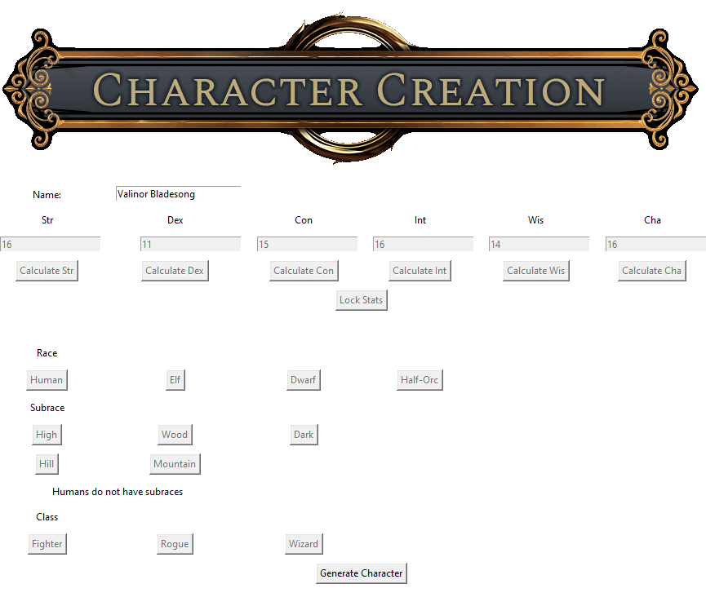

Buttons locked and unlocked properly, stats properly increased by race and subrace

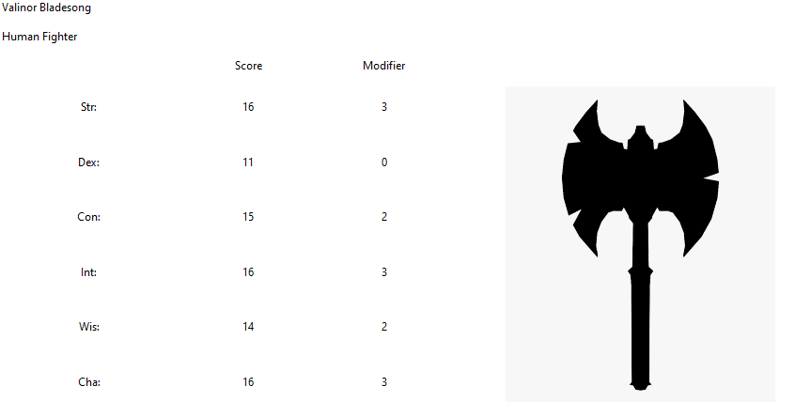

Sheet generated properly, modifier calculated correctly, correct image displayer

**Case 2**

Gunther Steadyfoot

Stats all randomly calculated

Race: Dwarf

Subrace: Hill

Class: Rogue

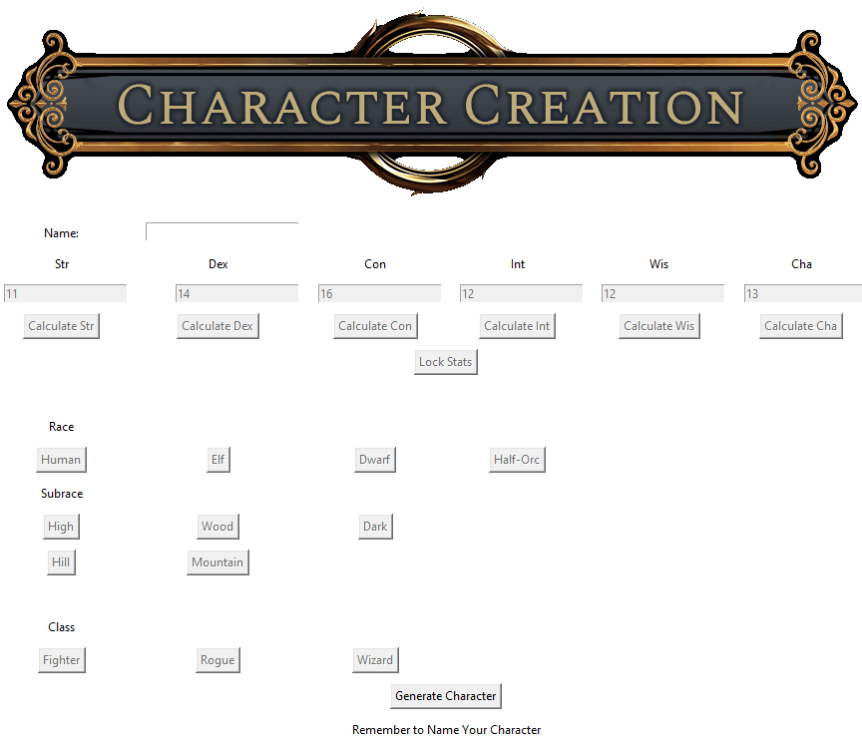

Properly reminds the user to name their character

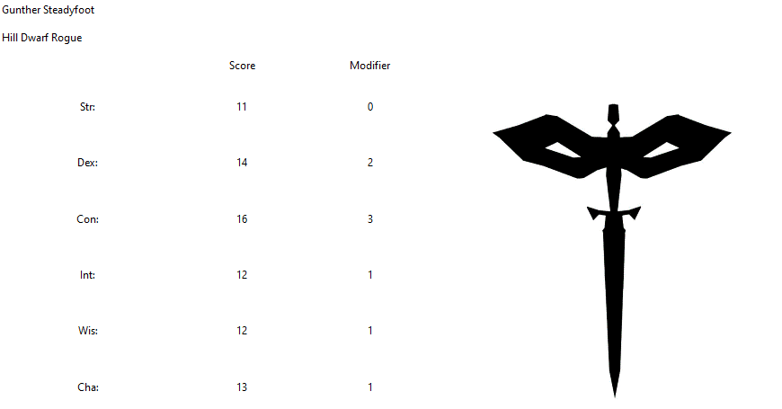

Sheet properly generated after name entered, correct image displayed

**Case 3**

Corvus Whitestreak

Stats improperly input the first go around

Race: Elf

Subrace: High

Class: Wizard

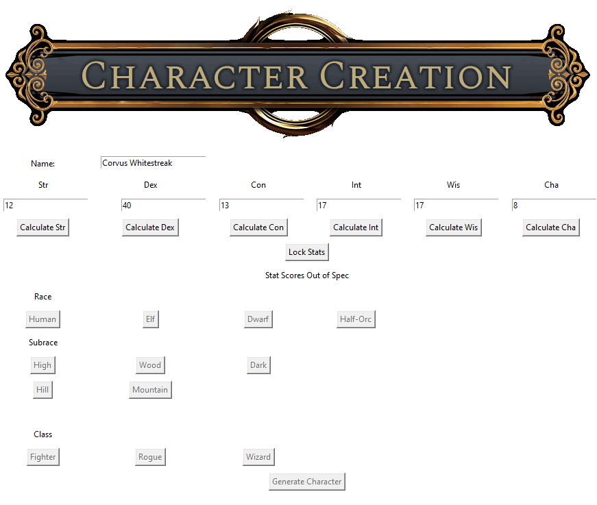

Stat imbalance properly caught

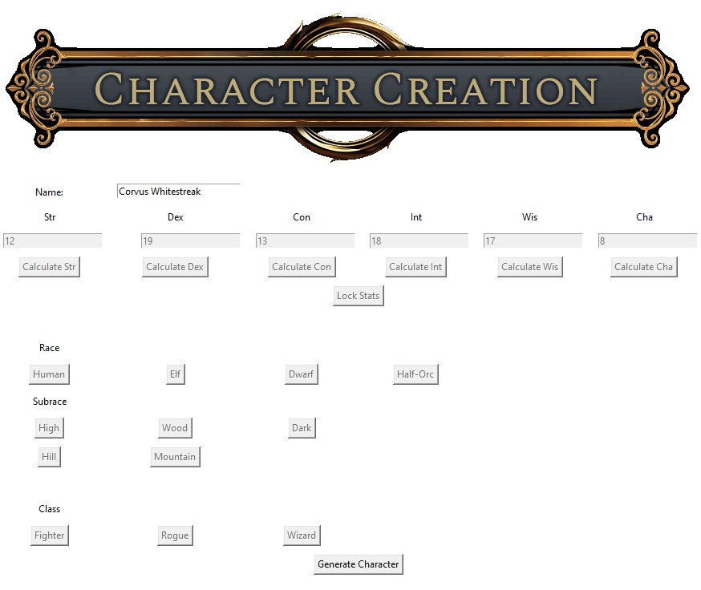

Creator worked as intended

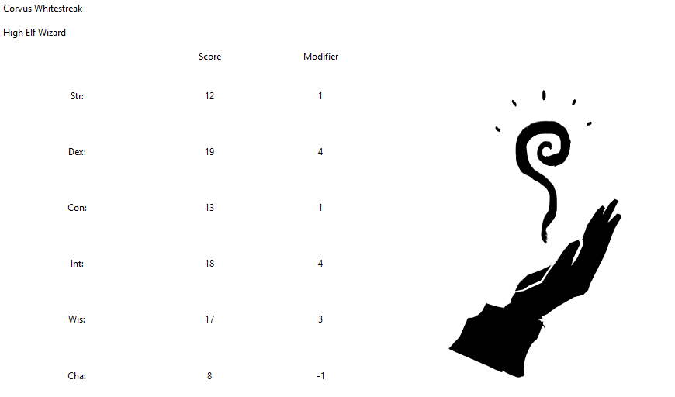sheet properly generated, modifiers properly calculated, correct image displayed